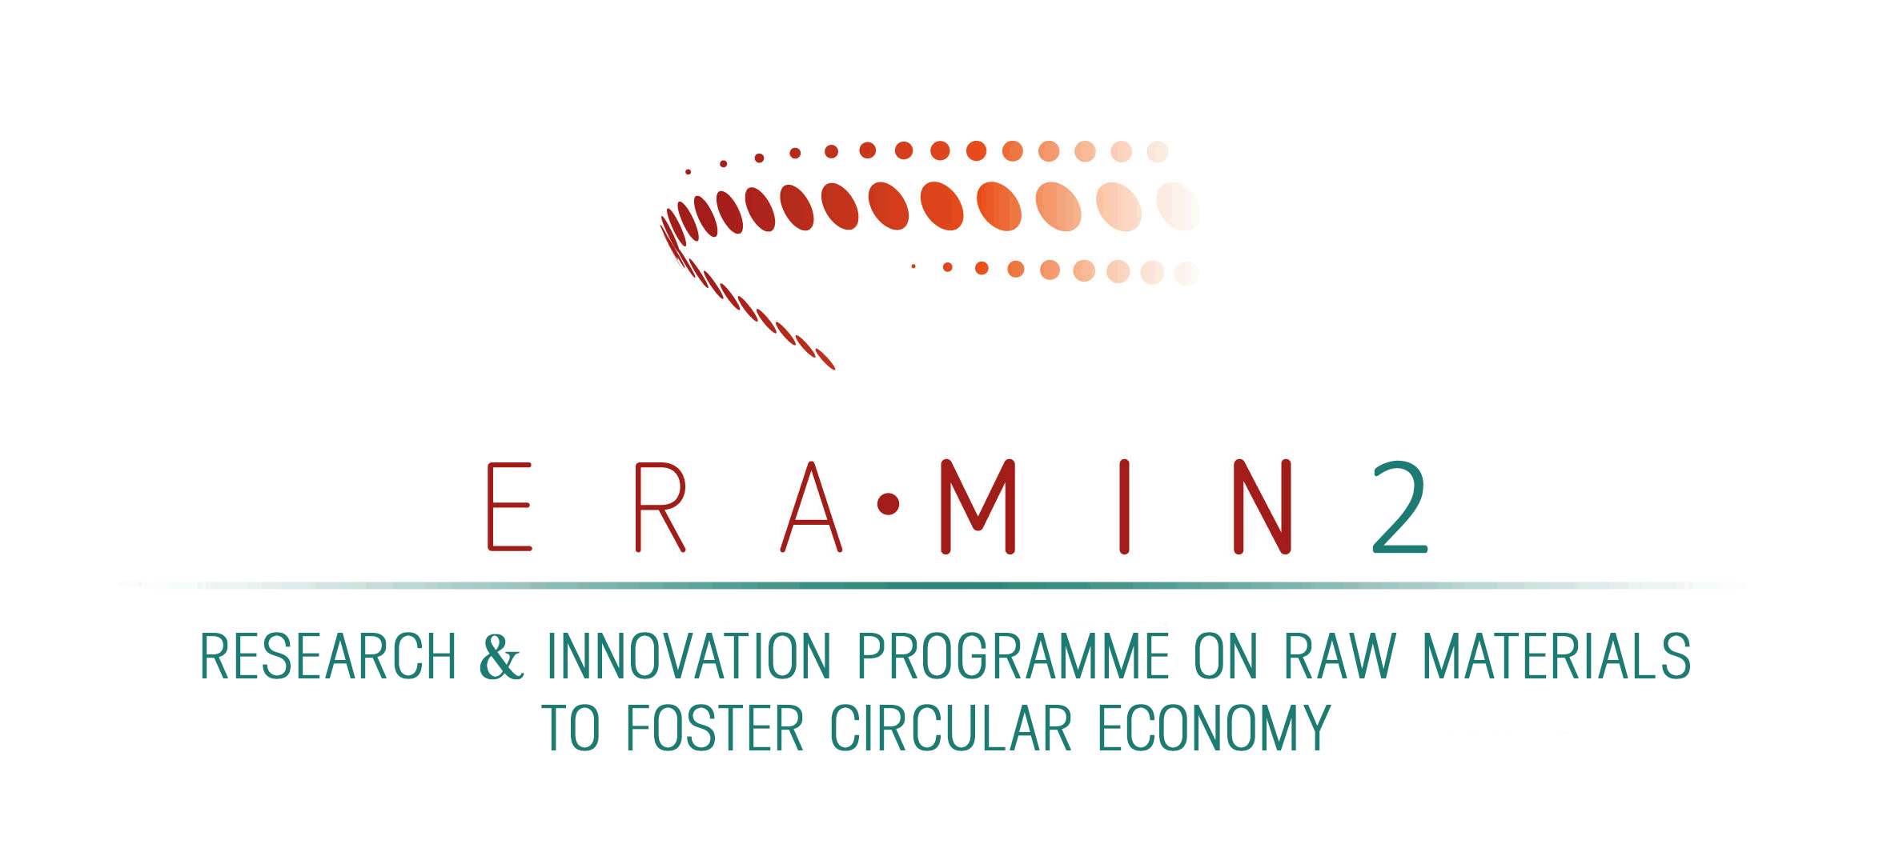
ERA-MIN Joint Call 2017

Raw materials for sustainable development
and the circular economy

CALL TEXT

Link to «Guidelines for Applicants»
Link to «National/regional funding regulations»
Link to the Electronic Proposal Submission System

For further information contact the Joint Call Secretariat:
eramin@fct.pt
Dina Carrilho (+351) 213 924 381
Marta Norton (+351) 213 911 565
FCT - Fundação para a Ciência e a Tecnologia
Av. D. Carlos I, 126 - 7º - 1249-074 Lisboa, Portugal

Table of Contents
1. Introduction 3
2. Background 5
3. The funding organisations 7
4. Scope of the ERA-MIN Joint Call 2017 and topics for funding 8
5. Call Topics supported by the funding organisations 11

      - Introduction
The focus of the ERA-NET Cofund instrument under Horizon 2020 is the implementation of a single joint call for transnational collaborative research and innovation projects in selected areas, with high European added value and relevance for Horizon 2020. Therefore, the selected projects under the ERA-NET Cofund joint call receive top-up funding from the Commission.
ERA-MIN 2 “Implement a European-wide coordination of research and innovation programs on raw materials to strengthen the industry competitiveness and the shift to a circular economy” is a progressive, pan-European network of research funding organisations that aims to develop the raw materials sector in Europe and globally. It builds on the experience of the FP7 ERA-NET ERA-MIN which was running from 2011 and 2015.
ERA-MIN 2 aims to support the European Innovation Partnership on Raw Materials, the EU Raw Materials Initiative and further develop the raw materials sector in Europe through funding of transnational research and innovation (R&I) activities. This will be achieved through one co-funded call in 2017, as well as two additional calls in 2018 and in 2019, designed and developed specifically for the non-energy, non-agricultural raw materials sector. The network will address four key objectives:
- Support and promote R&I cooperation in Europe
- Reduce fragmentation of R&I funding in the area of non-energy non-agricultural raw materials across Europe and globally
- Provide a pan-European support network and financial resources to improve synergies, coordination and collaboration
- Improve the eco-efficiency and impact of human and financial investment in R&I activities in the area of Raw Materials.
The ERA-MIN 2 consortium consists of 21 funding organisations from 18 countries/regions (13 EU countries/regions, one Associated country, and four non-EU countries). Nine partners of ERA-MIN 2 were also partners in ERA-MIN and eight other partners have participated in EU funded ERA-NETs since FP6, which gives the network an extensive experience with the coordination of national and regional funding programmes through the launch of joint transnational calls thus contributing to reduce fragmentation of R&I efforts across Europe.

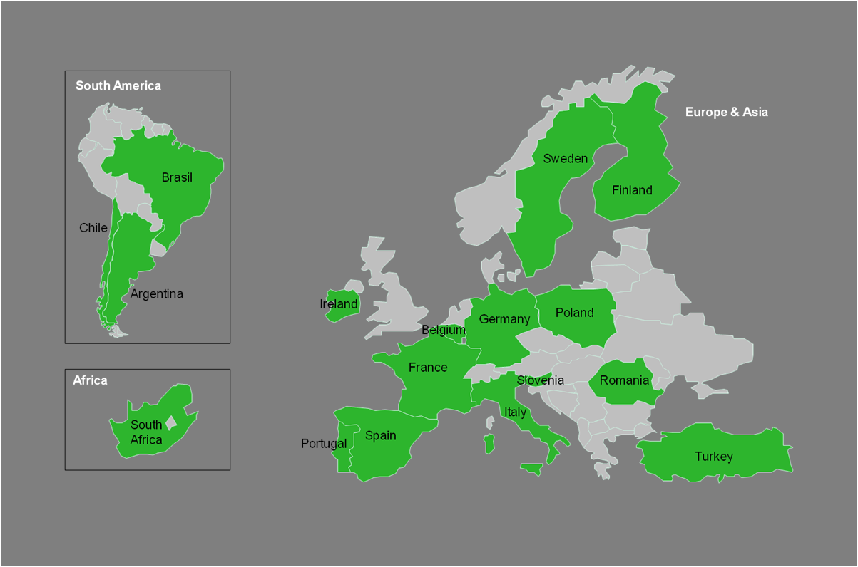
Figure1. ERA-MIN 2 consortium of funding organisations – countries/regions (FCT – Portugal; Vinnova – Sweden; JUELICH – Germany; UEFISCDI – Romania; MINECO – Spain; MINCyT – Argentina; NCBR – Poland; CONICYT – Chile; MIZS – Slovenia; ANR – France; CDTI – Spain; DST - South Africa; GSI – Ireland; ADEME – France; TUBITAK – Turkey; Tekes – Finland; Hermesfonds – Belgium/Flanders; ADE – Spain/Castilla y Léon; FWO – Belgium/Flanders; MIUR – Italy; Finep – Brazil).
In order to secure a sustainable and responsible supply of raw materials to the economy and industry, the ERA-MIN 2 joint call 2017 will address three segments of the non-energy, non-agricultural raw materials:
- Metallic,
- Construction, and
- Industrial minerals.
The call topics of the ERA-MIN Joint Call 2017 will be based on challenges and priorities identified in the ERA MIN Research Agenda which is available on the ERA-MIN website, at: http://www.era-min-eu.org/news/107-the-era-min-roadmap-published. It will be in line with the integrated strategy proposed in the EU Raw Materials Initiative, the Strategic Implementation Plan of the European Innovation Partnership on Raw Materials, as well as with the national and regional priorities. ERA-MIN 2 will liaise with the EIT on Raw Materials to offer complementary support and avoid duplication of efforts. ERA-MIN 2 is supporting the EU’s transition to a Circular Economy by addressing topics which are aiming at retaining the value of the raw materials we use in products and returning them into the product cycle at the end of their use, keeping in mind the need for a sustainable and responsible industrial supply of primary resources to feed the circular economy.

Background
Raw materials are particularly essential for the development of innovative environmentally friendly technologies and for the manufacture of the new and innovative products used in our modern society, such as batteries for electric cars, photovoltaic systems and components for wind turbines. Economic sectors such as construction, chemicals, automotive, aerospace, machinery and renewable energy correspond to more than 30 million jobs in the EU and depend on the sustainable supply of raw materials.
New technologies in almost any area of the daily life will require increasing use of non-energy raw materials. Research to develop knowledge on exploration and mining remains vital. The eco-efficiency of material production and use throughout the whole supply chain needs to be improved, turning this chain into a material’s circle where waste becomes the resource needed by another process, and dissipation is avoided as much as possible. Additionally, a significant reduction can be achieved by substituting scarce elements by more abundant ones with the same functionalities, or by substituting the functionality itself.
A group of 150 experts have contributed to the ERA-MIN Research Agenda and have identified the main challenges of research and innovation on non-energy raw materials. The identified challenges cover major parts of the circular economy as shown in fig. 2 including cross-cutting issues:
- Primary Resources: Improve techniques for exploration, mining and processing the primary resources that are necessary to satisfy the growing worldwide demand. As large, rich deposits located in countries that offer access to their mineral resources are getting rare, research is vital to explore for deeper-seated deposits (on-shore and off-shore), and to develop knowledge on unconventional resources.
- Design: Reduce or avoid the use of scarce materials. A significant reduction can be achieved by substituting scarce elements by more abundant ones with the same functionalities, or by substituting the functionality itself. This requires specific research in the field of elements and material properties. Another possibility is to support innovative design to facilitate handling and dismantling.
- Production, Remanufacturing / Use, Reuse and Repair / Recycling: Improve the eco-efficiency of material production and use throughout the whole supply chain to turn this chain into a materials circle where waste becomes the resource needed by another process, and where dissipation is avoided as much as possible. To achieve this, innovative recycling technologies for technology metals from complex products are as important as non-technical innovations, to obtain better access to secondary resources and ensure their resource efficient processing throughout the recycling chain, by reducing residual waste, water and energy use.
- Production, Remanufacturing / Recycling: Overcome metallurgical and especially extractive metallurgy challenges to enable a resource (whether primary or secondary) to give raise to the metals used by the downstream industry. This will contribute to reducing Europe’s metal import dependency and create jobs and business opportunities.
- Material cycle: Ensure, in harmony with the economic stakeholders and the society, the flow of minerals and metals needed by the economy, in line with the sustainable development framework. This requires reliable data and information on the global mineral resources industries, trade and non-trade barriers, market drivers, recycling and related facilities, trade flows, life-cycle and material flow data, etc., and the development of modelling integrating economic, environmental and social factors as well as objective functions controlling them. Such information and modelling is needed to develop and implement an EU non-energy mineral raw materials policy.

Fig. 2: Raw materials within the circular economy
With three joint calls and 17 transnational R&I projects supported with a budget of 13 million €, ERA-MIN (2011-2015) has successfully contributed to develop the raw materials community in Europe and beyond, in line with the objectives of the Strategic Implementation Plan of the European Innovation Partnership (EIP) on Raw Materials . During the lifetime of ERA-MIN the main focus of the funded R&I projects was shifted from the first part of the value chain, i.e. exploration and mining, to a more holistic approach covering also recycling and the substitution of critical raw materials. ERA-MIN 2 will build on these topics and cover the entire raw materials value chain, from sustainable exploration, exploitation, processing, substitution of critical raw materials and resource efficient production to short-term economic feasible and low environmental impact recycling. In line with ongoing efforts to close the cycle within a circular economy approach, ERA-MIN 2 will put more emphasis on the contribution of proposals to the EU’s transition to a circular economy by funding projects aiming at retaining the value of the raw materials we use in products, by returning them, as much as possible, into the product cycle at the end of their use.

The funding organisations
The funding organisations are those organisations that are partners of ERA-MIN 2 and have agreed to allocate national/regional budgets for the joint call 2017 on the transition to a circular economy in Europe and in the world, and will implement jointly the joint call for proposals based on commonly agreed structures and procedures co-funded by the European Commission.
Table 1. Countries/regions of ERA-MIN 2 consortium and the respective funding organisations.
Country/Region | Funding organisation | Short name
Argentina | MINISTERIO DE CIENCIA, TECNOLOGÍA E INNOVACIÓN PRODUCTIVA | MINCyT
Belgium/Flanders | FONDS VOOR WETENSCHAPPELIJK ONDERZOEK-VLAANDEREN | FWO
Belgium/Flanders | FONDS FLANKEREND ECONOMISCH EN INNOVATIEBELEID | Hermesfonds
Brazil | FINANCIADORA DE ESTUDOS E PROJETOS | Finep
Chile | COMISION NACIONAL DE INVESTIGACION CIENTIFICA Y TECNOLOGICA | CONICYT
Finland | INNOVAATIORAHOITUSKESKUS TEKES | Tekes
France | AGENCE DE L'ENVIRONNEMENT ET DE LA MAITRISE DE L'ENERGIE | ADEME
France | AGENCE NATIONALE DE LA RECHERCHE | ANR
Germany | PROJECT MANAGEMENT JÜLICH ON BEHALF OF FEDERAL MINISTRY OF EDUCATION AND RESEARCH | JUELICH/BMBF
Ireland | DEPARTMENT OF COMMUNICATIONS, ENERGY AND NATURAL RESOURCES/GEOLOGICAL SURVEY IRELAND | GSI
Italy | MINISTERO DELL'ISTRUZIONE, DELL'UNIVERSITA' E DELLA RICERCA | MIUR
Poland | NARODOWE CENTRUM BADAN I ROZWOJU | NCBR
Portugal | FUNDACAO PARA A CIENCIA E A TECNOLOGIA | FCT
Romania | UNITATEA EXECUTIVA PENTRU FINANTAREA INVATAMANTULUI SUPERIOR, A CERCETARII, DEZVOLTARII SI INOVARII | UEFISCDI
Slovenia | MINISTRSTVO ZA IZOBRAZEVANJE, ZNANOST IN SPORT | MIZS
South Africa | DEPARTMENT OF SCIENCE AND TECHNOLOGY | DST
Spain | CENTRO PARA EL DESARROLLO TECNOLOGICO INDUSTRIAL | CDTI
Spain | MINISTERIO DE ECONOMIA Y COMPETITIVIDAD | MINECO
Spain/Castilla y Léon | AGENCIA DE INNOVACION Y FINANCIACION EMPRESARIAL DE CASTILLA Y LEON | ADE
Sweden | VERKET FÖR INNOVATIONSSYSTEM | Vinnova
Turkey | TURKIYE BILIMSEL VE TEKNOLOJIK ARASTIRMA KURUMU | TUBITAK

Scope of the ERA-MIN Joint Call 2017 and topics for funding
The scope of the Joint Call is needs-driven research on non-energy, non-agricultural raw materials addressing one or several areas of the circular economy, as shown in Figure 2 above. As an overarching objective the proposed research should clearly demonstrate potential to foster the sustainable supply, processing, production and consumption of primary and secondary raw materials in a circular economy. All consortia should deliver convincing arguments on the potential impact of their innovation on the efficient supply, processing and use of raw materials. They should be able to quantify the expected impact using appropriate metrics and life cycle thinking. A specific work package on the follow up of these metrics in order to steer the project into the most environmentally beneficial direction could be an option.
The ERA-MIN Joint Call 2017 will address three segments of raw materials:
- Metallic,
- Construction, and
- Industrial minerals.

The research, development and innovation topics to be funded under the ERA-MIN Joint Call 2017 address all aspects of the non-energy, non-agricultural raw materials life cycle, covering both primary and secondary resources. Besides technological innovations, non-technological aspects will play an important role paving the way to a circular economy. Consortia may include players from the public and private sector with different backgrounds, e.g. physical scientists, engineers and technology developers, but also social scientists and policy advisors working closely together and covering different parts of the raw materials cycle.
The call focuses on four parts of the raw materials life cycle and horizontal cross-cutting topics. Nevertheless, following a systemic approach, other parts of the production cycle which were not mentioned explicitly (e.g. distribution, use, collection) can be included within project proposals. IT-based tools play an important role across the whole product life cycle to increase the efficiency of raw materials supply (e.g. inventories, supply chain management, automation). Special attention has to be paid to reconnecting raw materials to society. Therefore, applicants should indicate how their results will be disseminated to the public.

For the objectives and expected impacts of the 5 topics supported by ERA-MIN Joint Call 2017 please see the description below.
- Supply of raw materials from exploration and mining: The availability of primary resources and waste from exploration and mining activities remains a major prerequisite to satisfy the growing global demand for raw materials. Therefore, exploration and mining will not disappear in a circular economy. Within this topic we are seeking for new techniques for the exploration and mining of primary and secondary resources that are necessary for the industrial supply. Proposals can address new concepts, technologies and improved models to be used in mineral exploration; comprehensive characterisation and mapping of abandoned mine sites, making them also potential sources of various raw materials (including various by- or co-products in complex mineral matrixes) in an environmentally friendly and socially accepted way. Proposals should aim at significant or demonstrable progress towards the goal of responsible and sustainable development, through increasing the raw materials supply while reducing impacts on the environment. Within this approach contributions on the reclamation of former mine sites are included. Both onshore and offshore proposals will be supported (subject to national/regional regulations).
- Design: The design of products has a high impact on resource efficiency. Within this topic we are seeking for proposals that contribute to the efficient use of raw materials for recycling, or the substitution of critical materials in products and components. In terms of a holistic view, aspects like the extension of the product durability or the facilitation of its recycling should be taken into account as well. Attention should be paid to strategies and technologies for the substitution of 'substances of very high concern' (SVHCs) of the REACH regulation or which a scarcity may be foreseen. Applicants should be able to quantify the expected impact of the new product design on resource efficiency, using appropriate metrics and life cycle thinking.
- Processing, Production and Remanufacturing: Production efficiency and Remanufacturing processes in a circular economy provide a high potential to increase resource efficiency for primary and secondary sources. A major potential to increase the efficient use of raw materials is provided by resource intensive processes. Within a circular economy vision, waste occurring during the production phase could be recycled and therefore become a resource. In this topic we are looking for innovative technologies re-designing industrial processes. Therefore, a full understanding of the innovation and research needs across the life cycle is required to ensure that the greatest environmental benefits can be obtained. Proposals should address reduction of waste and/or recycling of waste, and additionally energy efficiency, environmental, and social impact could be considered. Proposals should be of high impact both in terms of the market opportunity they address, and the environmental/societal benefits they will enable.
- Recycling of End-of-Life Products: (e.g. waste of electric and electronic equipment (WEEE), batteries, end-of-life vehicles) is essential to turn the raw materials value chain into a materials cycle, where dissipation and waste is avoided as much as possible. A specific challenge is the recycling of raw materials from complex products. In this topic we are seeking for proposals to address this challenge through new concepts, technologies and services which increase the supply of raw materials from products and components at the end of their life. It is expected that the assessment of the potential impact of the proposed innovation on raw materials efficiency considers the whole life cycle of the products. Proposals could furthermore address additionally energy efficiency, environmental, and social impact could be considered.

- Cross-cutting topics that are relevant to any part of the raw materials life cycle can also be specifically addressed. Therefore, within this topic we are looking for proposals which propose non-technological innovations in order to increase the economic, environmental and social sustainability in the raw materials sector regarding:
- New business models,
- Improvement of methods or data for environmental impact assessment,
- Social acceptance and trust/public perception of raw materials.
A major challenge in the raw materials sector is that entrepreneurs, with novel, high-impact and potentially transformative approaches to raw materials supply, may face barriers, such as substantive investments in existing infrastructure, making the system resistant to change. Applicants are therefore encouraged to respond to this challenge and to develop new business models for a successful implementation of the developed technologies. Development of new, efficient methods for environmental monitoring (including real time monitoring) are encouraged. Gaining public trust in industrial activities is increasingly important in securing the raw materials supply in Europe from primary and secondary sources. Understanding the public perception of raw materials related activities will be supported in the cross-cutting topics. To address the topic of social acceptance/public perception, adequate expertise both from social scientists and geoscientist/engineers/industry is essential. Proposals will be evaluated by considering the potential presented for new, high-impact and potentially transformative business models, environmental and/or societal benefits in the raw materials sector.
More detailed information on sub-topic areas is shown in Appendix I. Not all funding organisations participate in each theme area and funding eligibility criteria may differ for some countries/regions. Applicants should check that the funding organisation for their country/region has confirmed its participation in the appropriate topic and sub-topic for their proposal; also which type of organisation may be funded at what level of support and the maximum budget available. A summary of these points is provided in Table 2 and in the national/regional funding regulations document but applicants are obliged to check with their national/regional contact point for this call. Background information on the research needs per topic and sub-topic areas was identified by the ERA-MIN research agenda, which can be downloaded from the ERA-MIN website at the following link: http://www.era-min-eu.org/news/107-the-era-min-roadmap-published.
Both basic and applied research projects will be funded by the call funding agencies (based on the national rules applicable), provided that the proposed research clearly demonstrates potential to foster sustainable industrial supply of non-energy mineral resources for the circular economy.
Target groups: All actors in the raw materials innovation chain, including academia, industry, NGOs, public authorities and civil society. Consortia involving both academic and industrial organisations are particularly encouraged to apply. Other types of consortia (e.g. purely industrial or academic) can also apply.

- Call topics supported by the funding organisations
Table 2 summarises which of the main five topics are supported by each funding organisation. In Appendix I there is a list of the sub-topics and a few examples of possible areas of research. A more detailed information on the supported sub-topics by each funding organisation is provided in the Guidelines for Applicants.
Table 2: Summary of the main call topics supported by the funding organisations.
Country/region | Funding Organisation | Topic 1 | Topic 2 | Topic 3 | Topic 4 | Topic 5
Argentina | MINCyT |  | x
Belgium / Flanders | FWO | x | x | x | x | x
Belgium /Flanders | Hermesfonds | x | x | x | x
Brazil | Finep | x | x | x | x | x
Chile | CONICYT | x |  |  |  | x
Finland | Tekes | x | x | x | x | x
France | ADEME |  | x | x | x | x
France | ANR |  | x | x | x
Germany | BMBF |  | x | x | x | x
Ireland | GSI | x | x | x | x
Italy | MIUR | x | x | x | x | x
Poland | NCBR | x | x | x | x
Portugal | FCT | x | x | x | x
Romania | UEFISCDI | x | x | x | x
Slovenia | MIZS | x | x | x | x | x
South Africa | DST | x |  |  |  | x
Spain | CDTI | x | x | x | x
Spain | MINECO | x | x | x | x
Spain / Castilla y Léon | ADE | x | x | x | x
Sweden | Vinnova | x | x | x | x | x
Turkey | TUBITAK | x | x | x | x
X – means topic and sub-topics eligible for funding.
means that not all sub-topics under the main topic are supported and there is a need to check the corresponding national/regional funding regulations document and the Guidelines for Applicants.
APPENDIX I - Sub-topic areas for research
      - Supply of raw materials from exploration and mining
1.1 | Exploration, e.g.  - Understanding primary and secondary raw materials resources for securing the supply chain,  - Tools for identifying resources and improving mineral resource modelling,  - Innovative approaches and tools for ore characterization  - Concepts and methodologies for assessing mineral resource supply risks
1.2 | Mining operations, e.g.  - Smart and eco-efficient technologies for mining  - Extraction of raw materials from historical dumps and tailings  - Enhanced landfill mining  - Technologies for the extraction of unconventional resources incl. intelligent mining
1.3 | Mine closure and reclamation, e.g.  - Remediation after mine closure with field demonstration at real-scale  - Predictions of mine closure long-term performance  - Long-term monitoring systems
- Design
2.1 | Product design for increased raw material efficiency
2.2 | Product design for reuse or extended durability of products
2.3 | Product design to promote recycling ( e.g. facilitation of dismantling)
2.4 | Product design for critical materials substitution, e.g.  - Developing products, services and technologies with same functionalities avoiding critical materials, or by substituting the functionality itself  - Replace 'substances of very high concern' (SVHCs) of the REACH regulation  - Reduce or avoid the use of materials with low abundancy and/or difficult/risky supply
- Processing, Production and Remanufacturing
3.1 | Increase resource efficiency in resource intensive production processes, e.g.  - Increase material and energy efficiency of ore processing  - Overcome metallurgical challenges for metal production from primary and secondary sources  - Valorization of by-products, co-products
3.2 | Increase resource efficiency through recycling of residues or remanufacturing, e.g.  - Scrap metals  - Residues from manufacturing  - Tailings from mining
3.3 | Increase resource efficiency using information and communication technologies (ICT), e.g.  - Supply chain management across the whole life cycle  - Smart technologies for processing, production and remanufacturing (e.g. sensor based sorting of metals scrap)
- Recycling of End-of-Life products
4.1 | End-of-life products collection and logistics
4.2 | End-of-life products pre-processing: pre-treatment, dismantling, sorting, characterisation
4.3 | Recovery of raw materials from End-of-life products, e.g.  - recover metals and rare earth elements from urban mines via innovative, clean and environmental-friendly processes (hydrometallurgy, pyrometallurgy…) and separation techniques
4.4 | Increase recycling of End-of-Life products through information and communication technologies (ICT), e.g.  - Databases and models on raw materials in buildings, infrastructure and products  - IT-based tools for efficient management of supply chains across the whole life cycle  - Smart recycling technologies (e.g. sensor based sorting)
- Cross-Cutting Topics
5.1 | New business models
5.2 | Improvement of methods or data for environmental impact assessment (e. g. LCA - life-cycle analysis)  - Studies on flows of mineral resources (e. g. MFA - material-flow analysis)
5.3 | Social acceptance and trust/public perception of raw materials, e.g.  - public perception for activities associated with raw materials supply  - Standardized social science methodologies for gathering/analysing data in different countries  - Case studies

On the review of the list of critical raw materials for the EU and the implementation of the Raw Materials Initiative” COM(2014) 297 final
The research is not restricted to the identified 20 critical raw materials (COM(2014) 297 final).

